OLDHAM COUNCIL
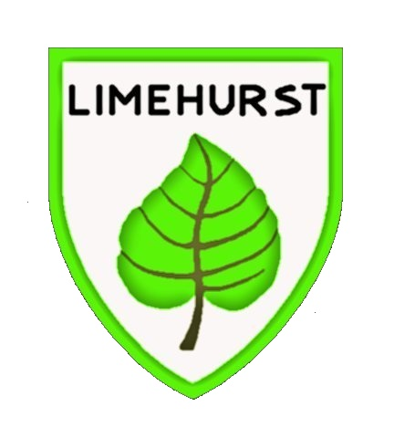
Limehurst Community Primary School
Whitebank Road
Limehurst Village
Oldham
OL8 3JQ
Telephone: 0161 7707220
Mobile No: 07494403422
info@limehurst.oldham.sch.uk
04/07/2025

Head teacher
Mr M Roberts

Dear Parent/carer,

SUMMER TERM NEWSLETTER THREE, 2025

Uniform List 2025/26

Nursery and Reception Pupils

Plain black or grey leggings or tracksuit pants
Yellow polo shirt
Plain bottle green cardigan, jumper, or sweatshirt (available with a Limehurst logo from school).
Plain black, grey, or white socks
Green or yellow gingham dress (summer term only)
Plain black or grey shorts (summer term only)

(Please do not accessorise any of the above with ribbons or frills. Thank you)

Velcro shoes
Wellington boots (to be kept in school)

Key Stage 1 and 2 Pupils (Year 1 to Year 6)

Plain black or grey skirt or trousers
White blouse, shirt, or polo shirt
Plain bottle green cardigan, jumper, or sweatshirt (available with a Limehurst logo from school)
Plain black, grey, or white socks
Plain black, green, or grey tights (or non-branded plain black full-length leggings worn under a school skirt during colder months of the year)
Green gingham dress (summer term only)
Plain black or grey shorts (summer term only)

(Again, please do not accessorise any of the above with ribbons or frills. Thank you)

Footwear

Shoes or trainers, predominately black. Shoes need to be sensible and appropriate for the school day including playing out at break and lunchtime.

To meet these requirements, footwear should be flat with good levels of grip. In addition, they should be stable and secure on the foot and offer protection to the toe and heel (again for playing outside at break and lunchtime).

General Appearance and Local Authority Health and Safety Instruction

Earrings – please ensure that if your child arrives at school wearing an earring/pair of earrings, they are small, discreet and lie ‘flat to the ear’. This guidance follows instruction from Oldham Council’s Health and Safety Team to avoid the earring being ‘caught’ during play at break/ lunchtime and the potential to cause significant injury.

‘Hoop’ type earrings, ‘large’ earrings and earrings that ‘protrude’ or ‘dangle’ from the ear are not permitted.

No jewellery is allowed in school other than a wristwatch. No rings (other finger jewellery) or necklaces.

No false nails (e.g. acrylic or gel). Nail extensions or decorated fingernails are not allowed for safety reasons (PE and playtimes etc) and potentially inhibit learning within some curriculum areas. Nails should be natural and kept short. Clear nail varnish is permitted.

Any children that have long hair should have it ‘tied back’ with a bobble or plaited. This is for safety reasons primarily as long hair may get ‘caught up’ and may also restricts vision. It may also have hygiene implications when the children are sat in close proximity. Our full Uniform and Appearance Policy is available on the school website. However, the list above is a summary of permissible items that may be worn in school. This is our uniform. Please do not wear any other items of clothing outside this list. Thank you.

*Please note that in the event of extreme weather (heat wave etc.) the Uniform Policy may be relaxed. If this is the case, parents/carers will be informed in advance.

Water in school

We care about our pupil’s health and wellbeing so we will always promote water as the best option and help pupils understand the importance of healthy drink choices and the benefits of consuming water. We also ensure our staff are committed to model healthy drinking habits.

During the school day

Limehurst is a water only school. This means that as a school we promote water as the ONLY readily available drink during the school day.

We strongly believe that water, which by law must be readily available to pupils, is enough to meet children’s hydration needs and pupils are encouraged to drink water as part of the school’s food policy. Be assured, hydration is not compromised by the lack of availability of sugary drinks in school. On particularly warm/hot days school staff will regularly remind children to drink water and stay hydrated. This will include opportunities to drink water before and after an outdoor pastoral time such as break and lunchtime.

At lunchtime

In compliance with the National School Food Standards, we provide water for all pupils during school meals (packed lunch pupils upon request). We actively discourage home packed lunch pupils from bringing fizzy or sugary drinks to school.
As a result children are not regularly drinking sugary drinks which contribute to many preventable health conditions like obesity, tooth decay and type 2 diabetes.

Also, we do not allow sports or energy drinks. Both have high levels of caffeine leading to dehydration. Dehydration may result in poor concentration in class, headaches, irritability, sleepiness, dizziness and can ultimately affect attainment.

End-of-school, 2024/25

The last school day for children in Nursery before the summer holiday is Thursday 17th July.

The last school day for children in Reception, Key Stage One and Key Stage Two before the summer holiday is Friday 18th July with an early finish as detailed below:

12.45pm finish for pupils in Reception

12.50pm finish for pupils in Key Stage One (classes four to six)

12.55pm finish for pupils in Key Stage Two (classes seven to twelve)

Thank you once again for your continued support over this school year.

Yours sincerely,
M Roberts
Mark Roberts
Head teacher
✄…………………………………………………………………………………………………………

Please tick one box below (as appropriate, A or B), sign and return to your child’s class teacher:

I acknowledge that my child…………………………………………………………………will finish school early on Friday 18th July 2025.

A) I will collect my child (mandatory for pupils in the Early Years, Key Stage 1 and Lower Key Stage 2), specific to timings detailed above.

please tick to consent and acknowledge

B) My child may walk home on their own (appropriate for some pupils in Year 5 and 6).

please tick to consent and acknowledge

Signed………………………………………………………………Parent/Carer

