Limehurst Primary School



Anaphylaxis Policy

Approved: Mark Roberts
Review Date: September 2026
Next Review: September 2027

- Overview
From September 2026, schools in England must follow mandatory statutory guidance under Benedict's Law and the Department for Education to improve allergy safety and anaphylaxis management.
Key Requirements for Schools
- Whole-School Allergy Policy: Maintain and publish a dedicated, stand-alone allergy policy on the school website rather than a general medical conditions policy.

- Staff Training: Provide annual allergy awareness and emergency response training for all staff members, including lunchtime supervisors, drivers, and caretakers.

- Emergency Spare Medication: Keep spare, in-date adrenaline auto-injectors (AAIs) on site to treat any child or adult experiencing unexpected anaphylaxis.

- Individual Healthcare Plans (IHPs): Implement precise care and management plans for every pupil diagnosed with serious allergies.

Limehurst Primary School is committed to providing a safe and inclusive environment for all pupils, including those with food allergies, intolerances and anaphylaxis. The school recognises that allergies can be life-threatening and takes reasonable steps to minimise the risk of exposure to allergens whilst acknowledging that it is not possible to guarantee a completely allergen-free environment.

The school works closely with pupils, parents/carers, healthcare professionals, catering providers and staff to ensure that medical needs are appropriately identified, managed and communicated.

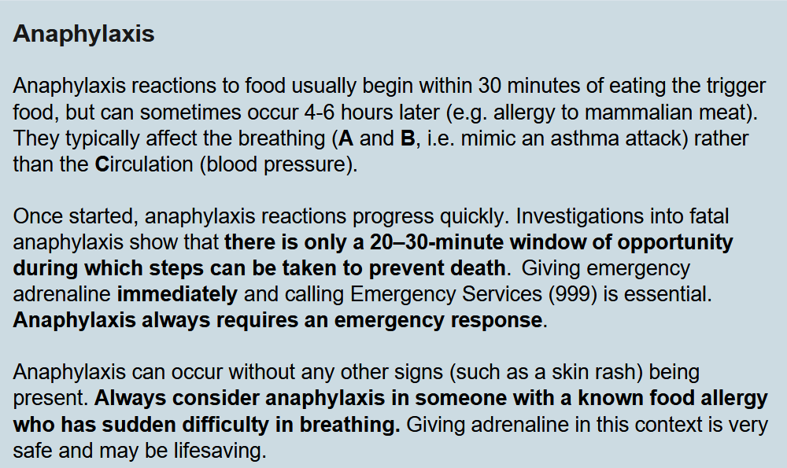
(DFE, Allergy Safety in Schools, July 2026)

2. Aims

This policy aims to:

- Support pupils with allergies and anaphylaxis to participate fully in school life.

- Reduce the risk of accidental exposure to allergens.

- Ensure staff understand their roles and responsibilities regarding allergy management.

- Ensure effective communication between school, parents/carers and catering services.

- Provide a clear response procedure in the event of an allergic reaction or anaphylaxis.

- To protect the health, safety and welfare of our staff and children.

- To identify all probable causes of allergy and take every reasonable effort to avoid the allergen.

- To have protocols in place for anyone with life threatening allergies.

- To ensure everyone caring for the child is aware of their allergies and symptoms which promotes a better understanding of the child’s needs.

- To ensure staff are trained to help allow for better management of the symptoms and recognition of the correct procedure for dealing with an emergency situation if it arises.

The implementation of this policy will ensure that the staff are provided with clear guidelines on the storage and use of Epipens and what to do in the event of an anaphylaxis emergency.
3.Staff Training
The school recognises the importance of ensuring staff have the knowledge and confidence to respond appropriately to allergic reactions and anaphylaxis.
All staff receive Allergy and Anaphylaxis Awareness training delivered by the School Nursing Service. Following the introduction of Benedict's Law, additional training has been provided in September 2026, to ensure staff understand their responsibilities in relation to allergy management, recognising the signs and symptoms of an allergic reaction and anaphylaxis, and responding appropriately in an emergency.
Training includes:
- Understanding common allergens and allergy risks within the school environment.
- Recognising the signs and symptoms of allergic reactions and anaphylaxis.
- Knowing the school's procedures for managing pupils with allergies.
- Awareness of Individual Healthcare Plans (IHCPs).
- The emergency administration of adrenaline auto-injectors (AAIs), where appropriate.
- Understanding the importance of allergen identification measures, including allergen wristbands and purple allergy trays during lunch service.
- Procedures for summoning emergency assistance and contacting parents/carers following an allergic reaction.
Refresher training will be provided as required and all new staff will receive appropriate allergy and anaphylaxis information as part of their induction.

4. Roles and Responsibilities
4.1 Parents/Carers
Parents/carers are responsible for:
- Informing the school of any diagnosed allergy that may result in an anaphylactic reaction.
- Providing appropriate medical evidence and healthcare information.
- Supplying at least two prescribed Adrenaline Auto-Injectors (AAIs), where required.
- Ensuring all AAIs supplied to the school are clearly labelled, in date and replaced before expiry.
- Completing all required school documentation, including consent for the administration of emergency medication.
- Informing the school immediately of any changes to their child's medical condition, medication or healthcare needs.
- Working with the school to ensure an up-to-date Individual Healthcare Plan (IHCP) is in place.
4.2 School Office
The School Office will:
- Maintain records of pupils with severe allergies and prescribed AAIs.
- Upload medical evidence and allergy documentation to SIMS.
- Maintain a register of AAI expiry dates and review this at the end of each half term.
- Notify parents/carers when replacement AAIs are required.
- Ensure relevant staff are informed of new or updated allergy information.
- Support the administration of emergency procedures following any allergic reaction.
4.3 SENCO
The SENCO will:
- Coordinate support for pupils at risk of anaphylaxis.
- Ensure an Individual Healthcare Plan (IHCP) is completed and reviewed for pupils prescribed an AAI.
- Ensure relevant staff are familiar with the pupil's allergy needs and emergency procedures.
- Maintain oversight of AAI storage arrangements and accessibility.
- Work with parents/carers and healthcare professionals to ensure medical information remains current.
- Authorise updates to pupil allergy records and healthcare plans.
4.4 School Staff Responsibilities
School staff will:
- Be familiar with the signs and symptoms of allergic reactions and anaphylaxis.
- Know how to summon assistance in the event of a suspected allergic reaction.
- Be aware of the location of pupils' prescribed AAIs and any emergency spare AAIs held by the school.
- Read and follow Individual Healthcare Plans relevant to pupils in their care.
- Take reasonable precautions to minimise exposure to known allergens.
- Ensure allergy identification measures, including wristbands and purple trays, are followed during lunch service.
- Attend allergy and anaphylaxis awareness training as required.
- Act promptly in accordance with training and school procedures if anaphylaxis is suspected.
- Be aware of the location of pupils' prescribed Adrenaline Auto-Injectors (AAIs) and the school's spare emergency AAIs stored within the School Office.
- Administer a pupil's prescribed AAI or, where appropriate, the school's spare emergency AAI in accordance with training and the pupil's Individual Healthcare Plan (IHCP).
The school has a number of qualified first aiders who may be called upon to assist in cases of allergic reaction, including anaphylaxis.
The school will contact parents/carers and emergency services where appropriate following any significant allergic reaction.
4.5 Catering Staff Responsibilities
Catering staff will:
- Be aware of pupils with severe allergies and anaphylaxis risks.
- Follow agreed allergy management procedures at all times.
- Ensure meals for pupils with recorded allergies are served in accordance with SchoolGrid allergen controls.
- Ensure meals for pupils with allergies are served on a purple tray to provide a clear visual identifier for all dining hall staff.
- Support the school's measures to prevent allergen exposure and minimise the risk of cross-contamination.
- Participate in allergy awareness training as required.
- Be aware of the location of pupils' prescribed Adrenaline Auto-Injectors (AAIs) and the school's spare emergency AAIs stored within the School Office.
5. Identification of Pupils with Allergies
Parents/carers must complete a Pupil Data Collection Form when their child joins the school.
Where an allergy or intolerance is identified:
- The School Office will discuss the condition with the parent/carer.
- Medical evidence will be requested.
- The parent/carer must complete a Food Allergy Notification Form.
- The parent/carer will receive a copy of the completed form.
- The school will retain a copy on the pupil's SIMS record.
6. Individual Healthcare Plans (IHCPs)
Children and young people should have an Individual Healthcare Plan (IHP) if:
- They have an allergy which has a functional impact on them in their school.
- They are at risk of harm as a result of their allergy and
- They require arrangements which are additional to or different from those made generally.
The IHP will set out the additional and/or different arrangements that will be in place in the school, college or early years setting for supporting the child or young person with their medical condition or allergy, including in emergency situations.
The schools allergy safety policy sets out how children and young people with known allergy will be supported through Individual Healthcare Plans. Where a child or young person has been issued with an Allergy and/or an Asthma Action Plan by a healthcare professional, it should be attached to their Individual Healthcare Plan.
- Medication
People at risk of anaphylaxis are usually prescribed self-administered adrenaline for use in an emergency. Currently two types of adrenaline devices (ADs) are licensed for use: an adrenaline auto-injector (AAI) and a non-injectable nasal adrenaline device. Clinical advice recommends that people at risk of anaphylaxis carry two devices with them at all times, regardless of the type of device, since two doses of adrenaline may be required.
All medication must:
- Be supplied by the parent/carer.
- Be clearly labelled with the child's name.
- Be in date.
- Be stored in accordance with school procedures.
6.1 Monitoring Expiry Dates
The SENCO and School Office will maintain a register of inhaler and adrenaline auto-injector expiry dates. The register will be reviewed at the end of each half term. Parents/carers of pupils whose medication is due to expire will be notified and asked to provide replacement medication before the expiry date.
7.1 Spare Adrenaline Auto-Injectors (AAIs)
Anaphylaxis reactions are unpredictable. In addition, up to 20% of anaphylaxis reactions in schools happen in children without a pre-existing diagnosis of allergy. We expect that all schools will stock “spare” adrenaline devices of the correct dosage for their pupils, for use in emergency situations – DFE Allergy Safety in Schools, July 2026
The school maintains a supply of spare, in-date Adrenaline Auto-Injectors (AAIs) for emergency use. These may be administered to any child or adult experiencing symptoms of anaphylaxis where appropriate and in accordance with current guidance, even if their prescribed AAI is unavailable, inaccessible, or has been used.
The spare AAIs are stored securely in the School Office safe and are readily accessible to trained staff in an emergency.
The School Office and SENCO will:
- Maintain a register of spare AAI expiry dates.
- Check spare AAIs at least termly to ensure they remain in date and suitable for use.
- Arrange replacement AAIs before expiry.
- Ensure staff are aware of the location of the spare AAIs and the procedures for accessing them in an emergency.

9. Symptoms Of Allergic Reactions
Mild to moderate allergic reactions which do not involve Airway/Breathing/Circulation can be treated with oral antihistamines. For a child or young person, telephone their parent or emergency contact to tell them about the reaction. Do not leave the child or young person unattended. The child or young person does not normally need to be sent home or require urgent medical attention. They should be observed in a safe place for at least 60 minutes after reaction, as mild reactions can sometimes develop into anaphylaxis.
Ear/nose/throat symptoms: runny or blocked nose, itchy nose, sneezing, painful sinuses. Headaches, post nasal drip, loss of sense of smell/taste, sore throat/swollen larynx (voice box), itchy mouth and or throat and blocked ears.
Eye symptoms: watery, itchy, prickly, red, swollen eyes. Allergic “shiners” (dark areas under the eyes due to blocked sinuses).
Airway symptoms: wheezy breathing, difficulty in breathing and or coughing (especially at night time).
Digestion: swollen lips, tongue, itchy tongue, stomach ache, feeling sick, vomiting, constipation and or diarrhoea.
Skin: urticarial- wheals or hives-bump, itchy, raised areas and or rashes. Eczema – cracked, dry, weepy or broken skin. Red cheeks. Angioedema – painful swelling of the deep layers of the skin.
9.1 Symptoms of severe reaction/anaphylaxis
This could include any of the above together with:
A: Airways: Swelling in the throat, tongue or upper airways (tightening in the throat, hoarse voice, difficulty swallowing)
B: Breathing: Sudden onset wheezing, breathing difficulty, persistent cough,noisy breathing
C: Circulation: Dizziness, feeling faint, sudden sleepiness, tiredness,confusion, pale clammy skin, loss of consciousness
Anaphylaxis reactions involve the Airway/Breathing/Circulation (“ABC”).
If in doubt, always treat for anaphylaxis - DFE Allergy Safety in Schools, July 2026
(see figure 1 below).

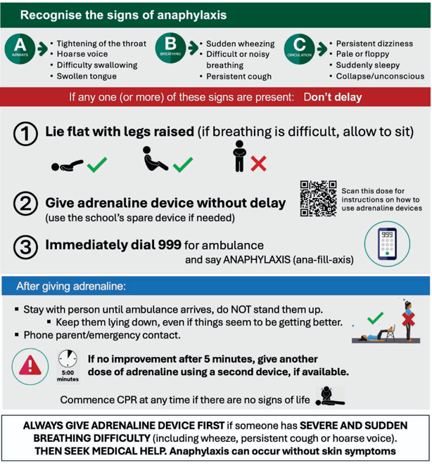
Figure 1: Management of anaphylaxis

8. Emergency Procedures
If a pupil displays signs of an allergic reaction:
- A trained first aider should be informed immediately.
- The pupil's Individual Healthcare Plan should be followed.
- Medication should be administered where required, in line with the IHP.
- Emergency services should be called if symptoms indicate anaphylaxis or if there is any doubt regarding the severity of the reaction.
- Parents/carers must be informed as soon as practicable.
- All incidents should be recorded in accordance with school procedures.
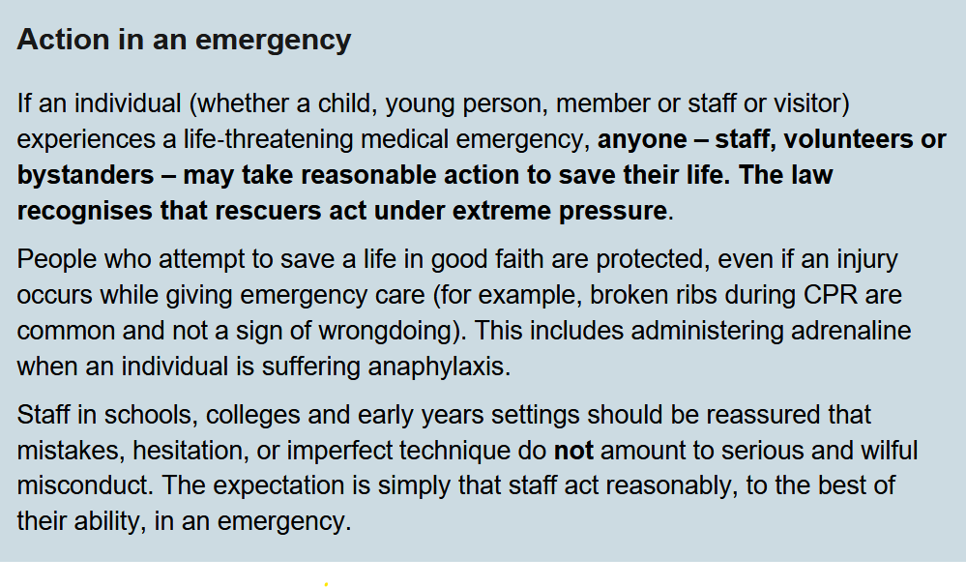
DFE, Allergy Safety in Schools, July 2026

10. Incidents and near miss reporting
A key expectation of the Department for Educations, Allergy Safety in Schools, July 2026 is that schools will record any allergic incidents and near misses, investigating all fully, before sharing details of the incident with both the parents of the effected child or young person as well as governors. All incidents should be recorded on CPOMS.
Further, the school will then review their allergy safety policy, to prevent any recurrence.
11. Related Policies
This policy should be read alongside:
- Department for Educations ‘Allergy Safety in Schools – July 2026’
- Children Act 1989
- Supporting Pupils with Medical Conditions Policy
- Administration of Medicines Policy
- Allergy Policy
- First Aid Policy
- Health and Safety Policy
- Educational Visits Policy
- Safeguarding and Child Protection Policy
- Keeping Children Safe in Education
- Risk Assessment Policy
- SEND Policy
- Intimate Care Policy (where applicable)

STAFF AWARENESS AND ACTION IN EMERGENCIES
All staff need to be able to manage attacks. Staff will do what a “reasonable parent” would do in the circumstances prevailing at the time.
The majority of allergic reactions are not anaphylactic. Most allergic reactions present with mild or moderate symptoms, which can be relieved with antihistamines taken at the first sign of a reaction, these should be kept with the child’s care plan.
If the anti-histamines are not relieving the symptoms and any of the above severe symptoms are evident, the following action is required:
Call for help immediately
- Ask someone to dial 999 and inform the controller that the patient is suffering from anaphylaxis.
- Ask someone to get the child’s Epipen. The child should not be left alone in any circumstances.
The first line treatment for severe symptoms is Epipen adrenaline (epinephrine) given by intramuscular injection into the upper outer muscle of the thigh.
Adrenaline given in this way is a safe treatment and you should not hesitate to use it if required. It starts to work within minutes, reducing swelling, relieving wheeze and improving blood pressure. It is also the only medicine which can stop the cells activated in an allergic reaction from releasing further mediators (chemicals) into the blood. So the earlier it is given, in an anaphylactic reaction, the better the outcomes.
Adrenaline is a short-acting drug and the effects will wear off quite quickly. If there is no response to the initial injection, current recommendations are to giver a further dose after 5 minutes.
Adrenaline is life saving and must be used promptly in anaphylaxis. Delaying the giving of adrenaline can result in deterioration and death. This is why the adrenaline device is the first line treatment for anaphylaxis.

